
34, VISHALA ESTATE, S.P.RING ROAD,OPP.ODHAV TO NIKOL ROAD, NIKOL, Ahmedabad, Gujarat, 382350
GST NO:-:24ARDPD2565K1ZX

info@torqpackagingsolution.com
www.torqpackagingsolution.com
Date:- 25/01/22
To.
Mr. Mathew

Sub: - Automatic Capping Machine

Dear Sir,
Many thanks for your valuable inquiry of above subject. TORQ PACKAGING Solutions is engaged in making preliminary Bottle Packaging machines like Bottle filling, capping, labelling, etc… in Ahmedabad, We are having dedicated team for manufacturing, customized machine development, Sales, servicing and back office.

Thanks & Regards
Parin Rahod
90161 38734

Price Table
Machine type | Quantity | Price
Automatic capping machine(up to 5 ltr) CAP pleasing manually | 1 | 2,50,000/-
Automatic Lug Capping Machine | 1 | 2,00,000/-

Required change parts for machine
Vibrator bowl (not required if cap size same) | 1 | 25,000/-
Capping suit (not required if cap size same) | 1 | 10,000/-
Capping head (not required if cap size same) | 1 | 10,000/-
Star wheel (require for every size of bottles-for up to 5 ltr machine) | 1 | 13,000/-
Star Wheel (required for every size of bottles – for up to 1 ltr) | 1 | 8,000/-

Automatic Single Head Screw Capping Machine

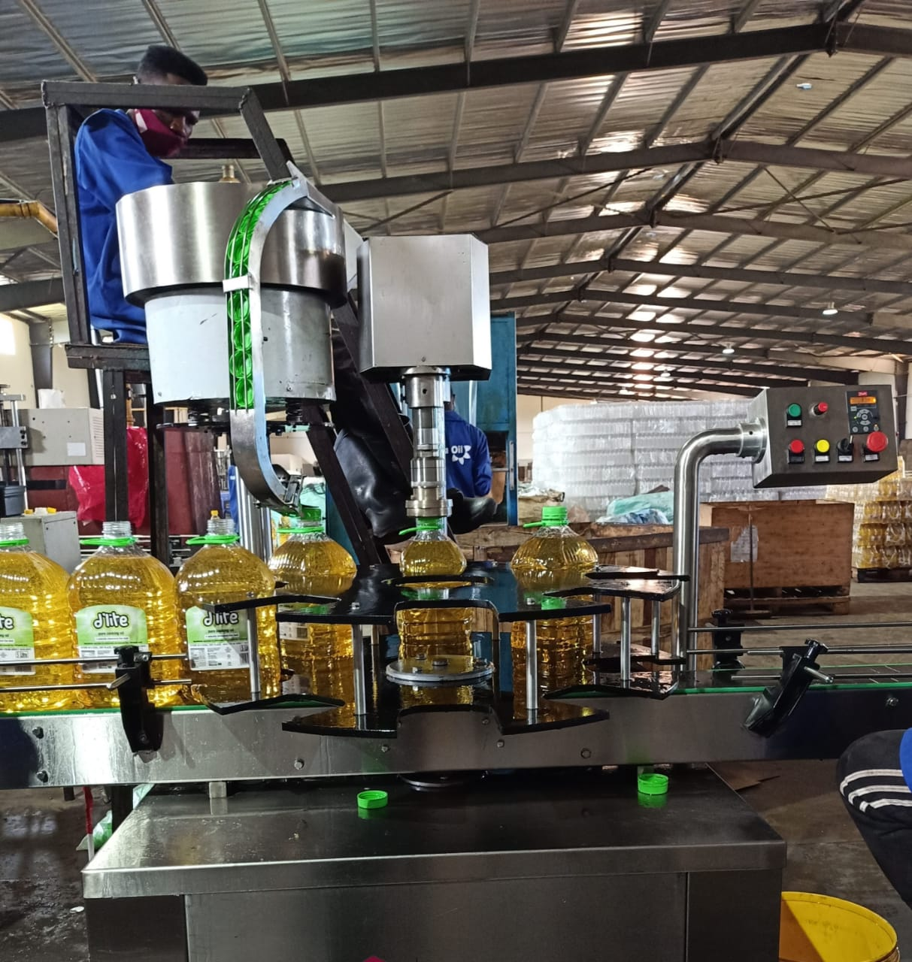
Description
Automatic Screw cap sealing machine is versatile, self-supported on stainless steel leg with height adjustable adjustment system. The machine is precision built on sturdy welded steel frame completely enclose in stainless steel sheet and doors are provided to facilitate the servicing of machine .
Operation
The feed container moving on conveyor belt are fed into star wheel, bringing the container below the sealing head in the subsequent indexing part, meanwhile the bottle pick up a cap from the delivery chute of cap feeding bowl, where the body and the neck of the container are positioned below the rotating head, where the sealing head is performing perfect operation of capping.
Technical Specifications
Output/Hour* |  |  |  | 1000 to3000 bottles
Direction of Movement |  |  |  | Left to Right
No. of Sealing Head |  |  |  | 1 Nos.
Power Consumption | Main Motor |  |  | 2 HP / 415 Volts / 50 Hz.  Crompton Make
 | Drive Make |  |  | Delta make 2 HP/50 Hz.
 | Cap Feeding Bowl |  |  | ------
Height of Conveyor |  |  |  | 860 mm to 910 mm
Machine Dimensions** |  |  |  | 2000 L x 1100 W X 1700 H
Case Dimensions |  |  |  | 2150 mm (L) x 1150 mm (W) x 1800 (H) Approx.
Net Weight |  |  |  | 350 Kegs. Approx.
Gross Weight |  |  |  | 500 kegs.
Change parts required |  |  |  | - Container: Star Wheel, Back Guide, Feed Worm  - Cap Die, Delivery Chute, Bowl
Input Specification
Screw Cap  Specification |  | Diameter** |  | 19 mm to 120 mm***
 |  | Height** |  | 15 to 18.3 mm
Container Size** |  | Round Shape |  | Ø 28 mm to Ø 100 mm  Respectively height 58 mm to 240 mm  (Height option for other bottle height available)
 |  | Flat / Square |  | 15mm to 100 mm (Length)  Respectively 10mm to 50 mm (Width)  Respectively height 58 mm x 240 mm  (Height option for other bottle height available)
* Depends on bottle size, cap size and type of cap.
** We can supply as per customer requirements.
*** With help of change parts.
Salient Features
- No container No cap arrangement.
- SS elegantly matt finished body.
- Single motor synchronizes conveyor, star wheel.
- Adjustable height of conveyor belt, to align with other machine of the line.
- Sealing pressure can be varied to suit different gauges and size of caps.
- Low noise level, low power consumptions.
- Self-lubricating UHMW-PE guide profile for low friction wears surface, smooth and noiseless conveying.
- SS cladding or hard chrome plating of all exposed parts to ensure long life and resistance against corrosion.
- Synchronized A/C drives to synchronize, Conveyor, Star wheel and Platform turret & capping bowl.
- Adjustable bottle height gauge for easy and quick setting.
Utility Requirement
Electrical supply |  |  | 1 Phase + Neutral + Earthling
Electrical load |  |  | 1.4 KW

Automatic Single Head Lug Capping Machine

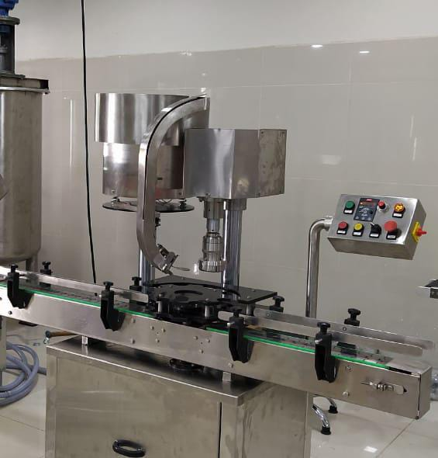
Description
Automatic Screw cap sealing machine is versatile, self-supported on stainless steel leg with height adjustable adjustment system. The machine is precision built on sturdy welded steel frame completely enclose in stainless steel sheet and doors are provided to facilitate the servicing of machine

Operation
The feed container moving on conveyor belt are fed into star wheel, bringing the container below the sealing head in the subsequent indexing part, meanwhile the bottle pick up a cap from the delivery chute of cap feeding bowl, where the body and the neck of the container are positioned below the rotating head, where the sealing head is performing perfect operation of capping.
Technical Specifications
Output/Hour* |  |  | 1000 to3000 bottles
Direction of Movement |  |  | Left to Right
No. of Sealing Head |  |  | 1 Nos.
Power Consumption | Main Motor |  | 1 HP / 415 Volts / 50 Hz.
 | Cap Feeding Bowl |  | 300 watt, Magnetic coil
Height of Conveyor |  |  | 860 mm to 910 mm
Machine Dimensions** |  |  | 2000 L x 1100 W X 1700 H
Case Dimensions |  |  | 2150 mm (L) x 1150 mm (W) x 1800 (H) Approx.
Net Weight |  |  | 300 Kgs. Approx.
Gross Weight |  |  | 400 kgs.
Change parts required |  |  | - Container: Star Wheel, Back Guide, Feed Worm  - Cap Die, Delivery Chute, Bowl
Input Specification
Screw Cap | Diameter** |  | 19 mm to 38 mm***
Specification | Height** |  | 15 to 18.3 mm
Container Size** | Round Shape |  | Ø 28 mm to Ø 100 mm  Respectively height 58 mm to 240 mm  (Height option for other bottle height available)
 | Flat / Square |  | 15mm to 100 mm (Length)  Respectively 10mm to 50 mm (Width)  Respectively height 58 mm x 240 mm  (Height option for other bottle height available)
* Depends on bottle size, cap size and type of cap.
** We can supply as per customer requirements.
*** With help of change parts.

Salient Features
- No container No cap arrangement.
- SS elegantly matt finished body.
- Single motor synchronizes conveyor, star wheel.
- Adjustable height of conveyor belt, to align with other machine of the line.
- Sealing pressure can be varied to suit different gauges and size of caps.
- Low noise level, low power consumptions.
- Self-lubricating UHMW-PE guide profile for low friction wears surface, smooth and noiseless conveying.
- SS cladding or hard chrome plating of all exposed parts to ensure long life and resistance against corrosion.
- Synchronized A/C drives to synchronize, Conveyor, Star wheel and Platform turret & capping bowl.
- Adjustable bottle height gauge for easy and quick setting.
Utility Requirement
Electrical supply |  | 1 Phase + Neutral + Ear thing
Electrical load |  | 0.75 KW

Terms & Conditions
1 | PRICE | The prices mentioned are ex our Ahmadabad works
2 | TAXES & DUTIES | 18% extra
3 | TERMS OF PAYMENT | We agreed to have 50% advance and 50 % before Dispatch.
4 | DELIVERY  PERIOD | Within 3-4 Weeks from the date of receipt of technically & commercially clear order along with advance payment or receipt of approval for input dimensions, whichever is later
5 | INSURANCE | Transit Insurance against Theft, Pilferage, Breakage, Etc. will be arranged at extra cost at your explicit instruction, otherwise it will be assumed that goods are to be sent at your risk. Cost of such insurance will be as actual to be borne by the consignee.
6 | TRANSPORT | Transportation of the machine from our factory has to be arranged by you. We will arrange for loading of the equipment at our factory. However unloading at site has to be arranged by you. Our responsibility ceases once the goods leave our factory and are handed over to carrier. We do not undertake any liability for damage/ loss in transit whatsoever, whether the goods are insured or not. In case of any damage / accident during transit, the client has to directly deal with the insurance company without holding any payments, irrespective of the insurance arranged by Consigner or Consignee.
7 | INSPECTION | We offer inspection of the machine at our factory, by your technically competent representative, prior to dispatch. This person should be present on our factory during packing and loading of the machine. In case you are not deputing anyone for pre dispatch inspection, then we will not entertain any dispute arising out of short supply, quality, workmanship, functionality, operating parameter, etc. once the machine is dispatched.
8 | FACTORY  TRAINING | We will impart training to your operating staff in our factory before the machine is dispatched, at no additional cost. However, his lodging-boarding and local traveling expenses will have to be borne by you. This person should be technically competent to uncrate and assemble the machine at site before the arrival of our commissioning engineers. He must ensure that ground work necessary at site is competed in all respects before machine. Commissioning, He must be competent enough to be able to run the machine and carry out routine maintenance, once the machine is handed over after commissioning
9 | INSTALLATION | The machine has to be uncarted and placed in working position by you at site. You have to carry out all the external powers and air compressor at site. The machine must be available in the fully assembled condition when our commissioning engineer arrives at site.
10 | COMMISSIONING | For supervising and commissioning of the machine we will depute one of our engineers on chargeable bases. Customer will have to send a prior intimation of readiness of electrical and utility connections along with required materials.  Rs. 2,000/- per man day will be charged. Customer will reimburse to and for 1st class fare from Ahmedabad to the destination, lodging and boarding expenses and other local expenses for the period of commissioning.
11 | SPECIFICATION | In line with our policy of continual improvements, we reserve The right to modify the design and change the specifications and make of any material, if in our opinion such modification leads to an improvement in the performance of the machine. Therefore specification, illustrations, dimensions, offers, drawings or photographs are not binding in detail.
12 | WARRANTY | Our goods carry a warranty of one-year trouble free operation from the date of dispatch. The warranty is only against manufacturing defect. It does not cover any electrical, electronic or bought out components. Components getting normal wear and tear would be replaced at your cost.
13 | NOTE | Customer have to provide samples of bottles, caps, labels etc. along with the purchase order otherwise machine will be made as per our standard specifications, wherein we will take trial with water, caps, bottle, label etc available with us, which will be acceptable to you.
14 | CANCELLATON  OF ORDER | Order once placed, cannot be cancelled under any circumstances. In case of orders being cancelled, then the entire amount of advance payment will stand forfeited.
15 | OFFER VALIDITY | This offer remains valid for the period of 30 days. Any extension thereafter will be subject to our written confirmation only.
16 | JURISDICTION | No legal proceedings shall be taken to enforce claims and no suit arising out of any contracts shall be instituted except in a court of competent jurisdiction located within Ahmedabad, Gujarat.

